**Project title**: Pheha Plastic

**Date**: 10/10/2021

**Project team members**: Ravanpreet Kaur, Tlotliso Namane, Lehlohonolo Thakhisi

**Description:**

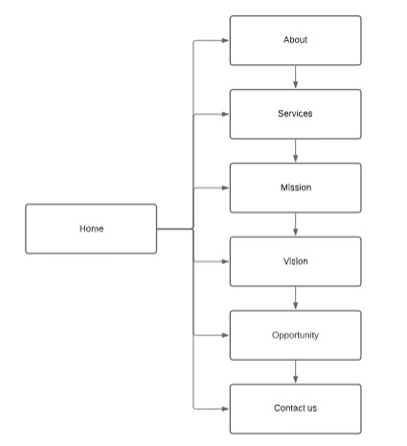

The websites main function is to target awareness in recycling plastic and reuse it to create useful products. The flowchart above shows how the website is designed and the home page contains the navigation bar of every section, clicking on them directs you to a different section scrolling through the website.

**Home page**: The section shows a slide about plastic recycling and different features of images in the background and a navigation bar of different sections in the website and the company logo as well. Each section is accessible either clicking on the bar or scrolling willingy.

**About section**: The about tells the viewer about Pheha Plastic and its establishment, creating loads of different products from recycled plastic turning them into beautiful masterpieces. This section can easily be accessible by clicking on the navigation bar.c

**Services section**: This section shows the viewers what Pheha Plastic can do and what they can create with recycled plastic and the photos provided are in black and white but hover over them and they zoom in giving out their natural colours and the name of the product below will show a bottom border. The images also move by dragging your curser on the images moving them them either from the left or right and as they move shadows follow them.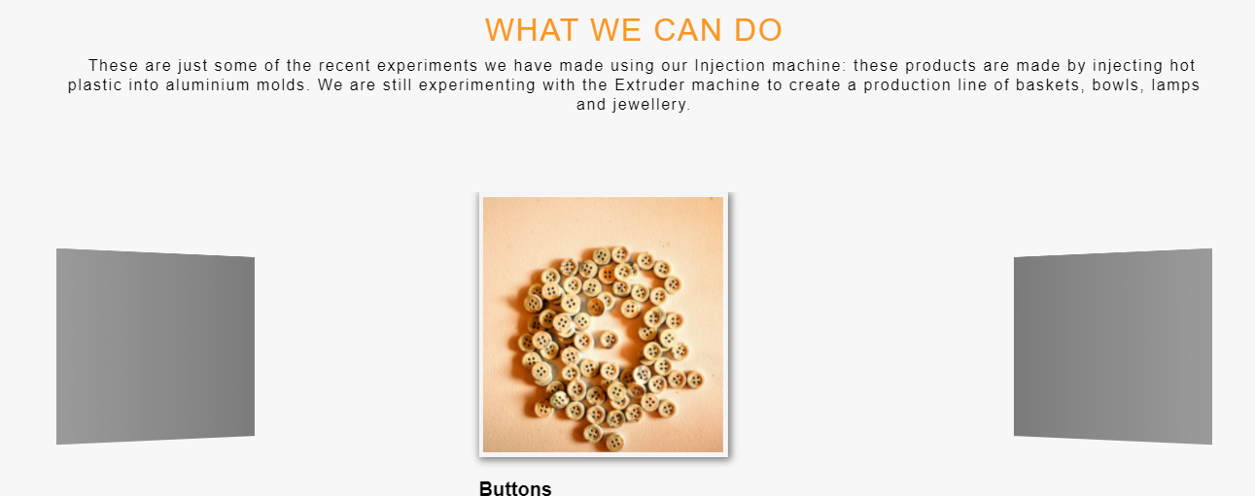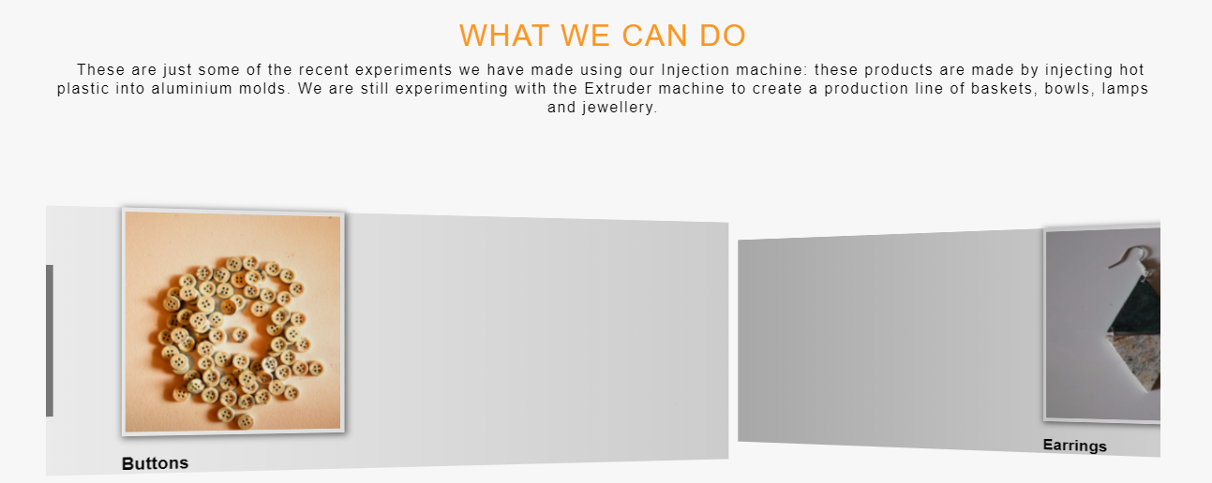

**Mission section**: The section tells the viewer what their mission is by creating a better world where plastic can recycled and reused thereby reducing it making the world green. The mission section shows images that explain different missions and when the viewer hovers over them the images as well as the content zooms in and the content is 1px larger. The section reappears by rotating and being vsisble to the viewer.

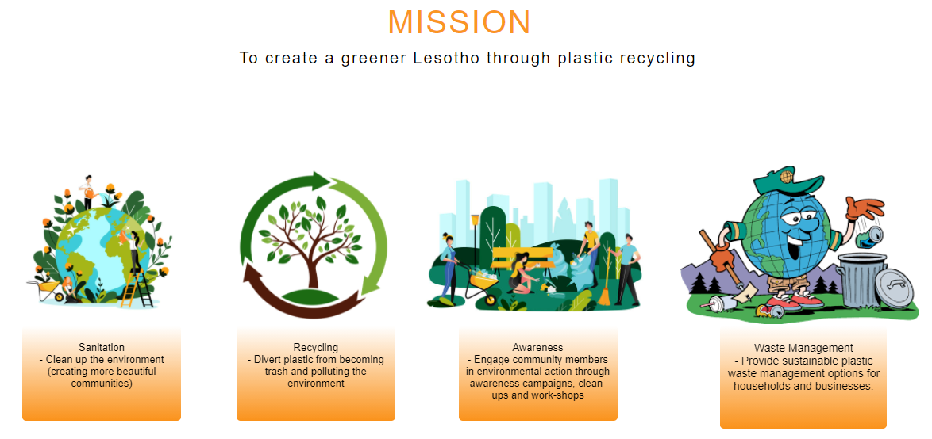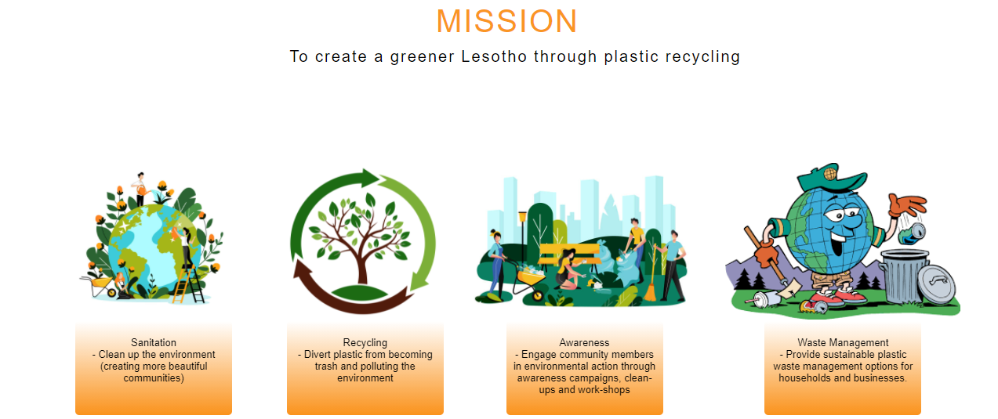

**Vision section**: The vision section tells the viewers their aim to provide economic boost to the community as the image shows a hand boosting the world to greater heights and establishing programs for students and the community to undertake and volunteering in plastic recycling in exchange for credit, tokens and vouchers. This section reappears from the right when approached.

**Opportunity section**: The section tells the viewer about programs to undertake, opportinities for people to join in and help make the world greener and the image provided shows the community taking part in the program by recycling plastic in the required bin. This section reappears from the left when approached.

**Contact section**: The footer contains the contacts information and social media platform links for viewers to get in touch and the email and phone are provided in shadowed boxes that zoom out when the viewer hovers and the social media platform icons contains links that will direct the viewer to the page or account of Pheha Plastic. The icons change color when the viewer hovers over them as well.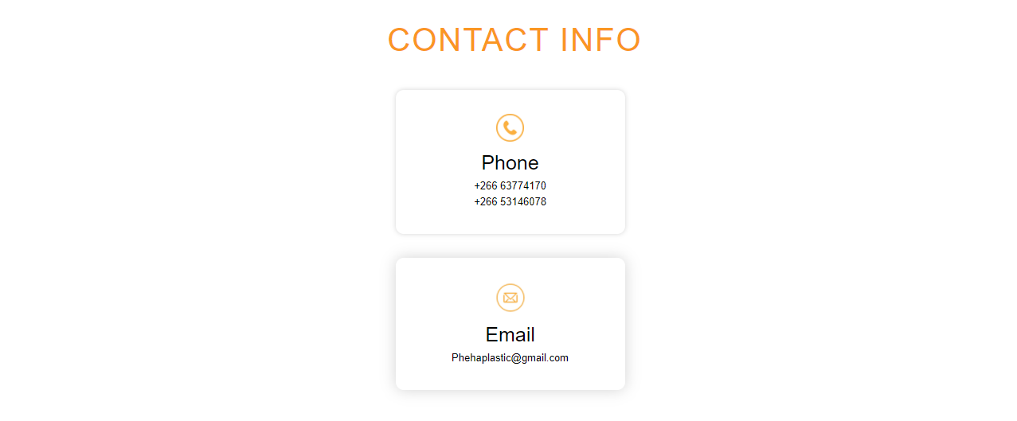





**Purpose:**

The purpose of this website is to raise awareness in recycling plastic, reusing it by creating useful products and help reduce it in the world and help the world be greener and beautiful again because throwing away plastic has become unsanitary as well as dangerous.

The website is functional on a laptop, tablet and phone

**Frameworks: HTML, CSS, Javascript**